Use Case Diagram
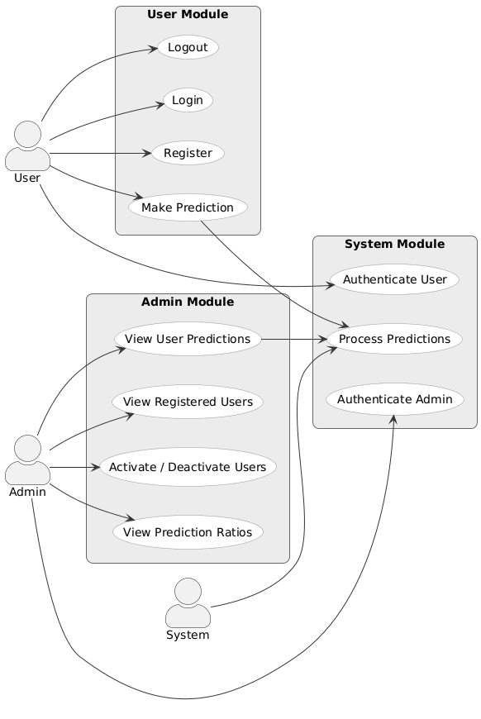
Class Diagram
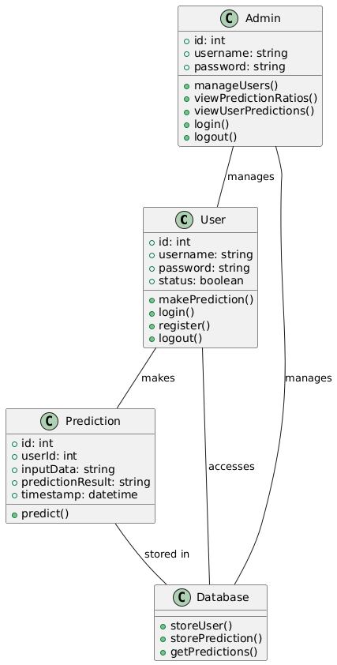
Activity Diagram
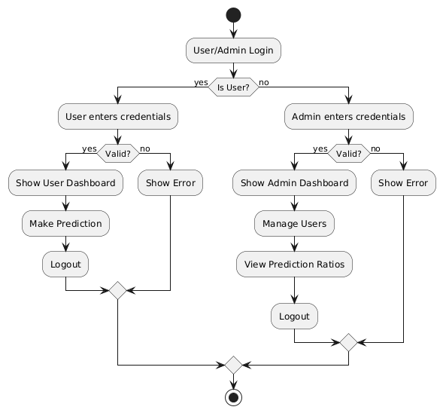
Sequence Diagram
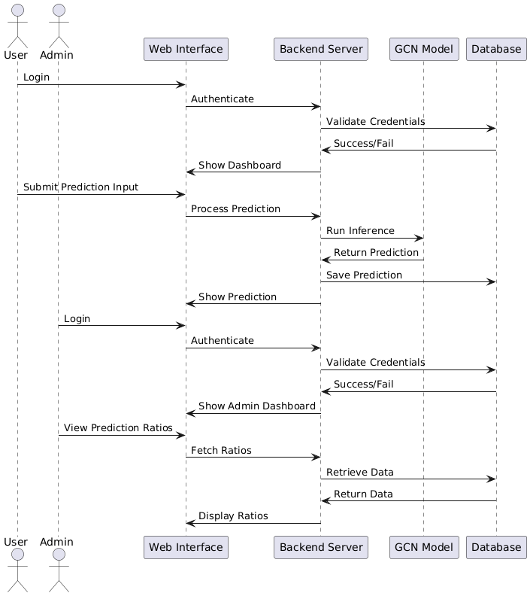

Collaboration Diagram
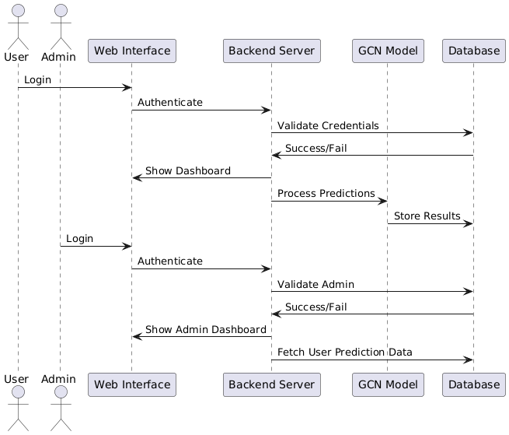
Component Diagram
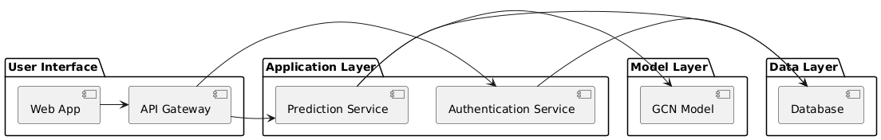

Deployment Diagram
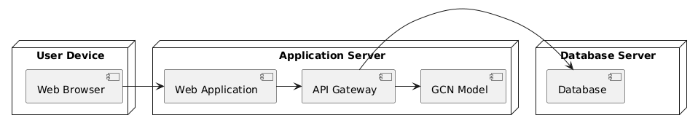
Data Flow Diagram Level 0 (DFD-0)
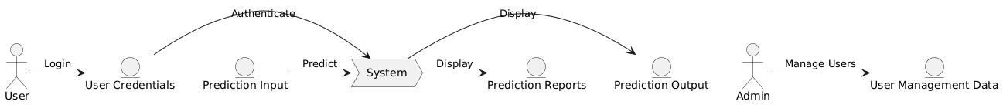
Data Flow Diagram Level 1 (DFD-1)

